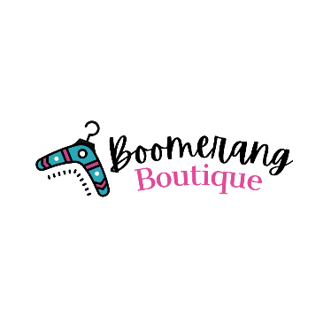

Your Comeback Consignment Shop
To Rent with Boomerang, you must agree to and initial ALL terms:

- __________ There is a 25% (of the original selling price) rental fee per item.

- __________ The full selling price of each item will be the deposit for each item borrowed/rented.

- __________ The rental period is for 5 days, if you are unable to return the items by the specified date, please contact the store to arrange for a longer period. A late fee of 10% per day may be added to the original rental fee.

- __________ All items must be returned in the same condition as when it left the store. Failure to do so will result in the full selling price being charged on item(s).

- __________ For all items returned in their original condition, the deposit (less the 25% rental fee) will be refunded.

By signing this contract, I have read and agreed to the above conditions.
Name:____________________________ Phone Number:________________
E-mail: __________________________________ Date:___________________
Signature:________________________________________________________

STORE USE ONLY:
Date of Rental: ____________________ Deposit Amount: _______________
Return of Rental: __________________ Refund Amount: _______________

